Weekly sponsor communication
to: | Victor Nunez, Aesculap
from: | Brian Loughran
Editor:  team name and Number: | Cassie Christman  Aesculap 1
dates covered in this communication: | September 18, 2016 to September 24, 2016
Week Number: | 4 of 15
Overview
Thank you very much for the feedback you gave to us this week. We know that we had an especially high number of questions, and we appreciate how helpful you have been. Our team is beginning preparations for the midterm presentation, while also continuing to make design changes and upgrades to our CAD model first introduced last week.

Accomplishments

- For the midterm tabletop presentation, we had the idea that we could simulate the surgery for those visiting the table. Using the sawbone lumbar spine model you gave us, and the 3D printed prototype we hope to collect from the Aesculap site on Thursday, we will give a semi-realistic surgical experience to those who visit the table, and we hope this helps onlookers to better understand our project. To assist in the experience, Jadon has purchased a mannequin which we will place the spine in to give the users a bit more perspective. Alexis is borrowing some blue tissue paper from her lab to cover our mannequin “patient” with.

- Christian has made some upgrades to the model included in last week’s brief. Below is a picture of where we are at currently with the model, and included alongside this brief is a .stp file of the model. You mentioned earlier that you were OK with using Aesculap’s facilities to 3D print a model of the distracter, would you mind printing this model by when we come to visit the site on Thursday? Thanks a bunch for your help.

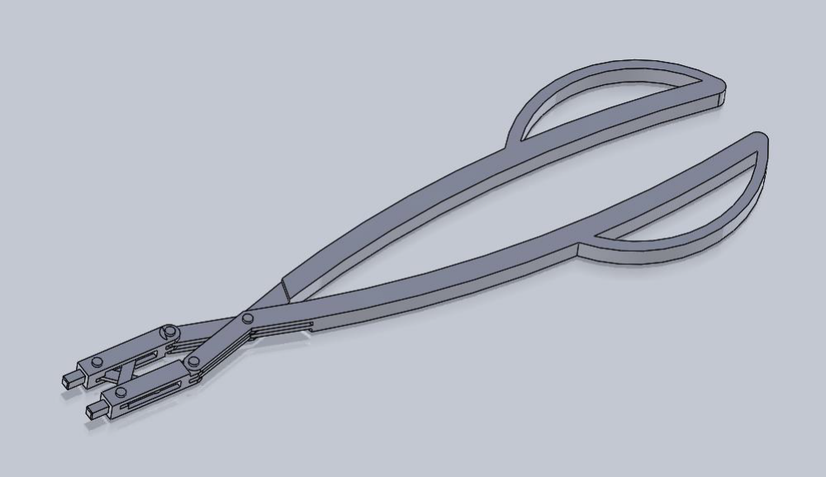
Figure 1 – 3D model of distractor design (paddles not included)

- Also in preparation for the midterm presentation, Brian has redone the financials to reflect the way that the product is sold. We estimated that we would have to fabricate about 30 distracters to replace the current angled distracters. We also used numbers given to us by Chris Goode and Monika Martin to estimate the increase in Activ-L implants sold because of the improved surgical kit to estimate profits. Long story short, we are still making money. Shown below is a chart of period and cumulative cash flow to demonstrate this. The axis on the left is in units of $1000:
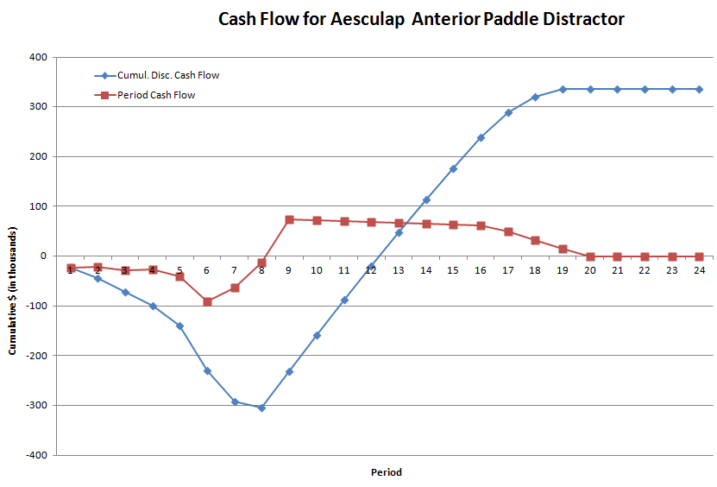

Figure 2 – Period cash flow reflects cash in/out for each quarter, cumulitive cash flow reflects the total money made/lost due to this venture for any given quarter.

Next Steps
- We will continue to make preparations for the midterm presentation, which is scheduled for October 7th.
- We will be visiting the Aesculap site on Thursday, and we are aiming for a 2:00 PM arrival time. At this meeting we will pick up material samples, a banner, an angled distracter, and our 3D printed prototype. If any of these things are too difficult to collect on your end, Victor, don’t worry too much about it. These are all things that we think could enhance our presentation, but none of them are absolutely necessary.
- We hope to get feedback on our initial design, and come up with ways to improve the design.

Questions

- This was mentioned earlier in the brief, but is reiterated here for format sake: If we get you a .stp file of our distracter by Monday, using Aesculap’s facilities, can you make a 3D printed model by the meeting on Thursday?

- Is this model easily 3D printable?

- For the CAD model we were thinking about doing some simulation, but we didn’t have any material properties for the material used in the previous distracter (420c Stainless Steel). Would you mind sending maybe a screenshot of the material properties so we could manually input these into Solidworks?

